**“CASIO Website”**



**A**

**PBL Report**

# Submitted to the

**SAGE University, Bhopal, M.P.**

**in partial fulfillment of the requirements for the award of the Degree of**

**“B.Tech (CSE)”**

**With specialization in**

**(Full Stack Development)**

# By

**Pranjal Soni [23BTA3BFS10018]**

**Shrasti Gupta [23BTA3BFS10025]**

**Payal Suryawanshi [23BTA3BFS10016]**

**UNDER THE GUIDENCE OF**

**MR. Kapil Agrawal**

**SCHOOL OF ADVANCED COMPUTING AUTUMN 2023-24**

# SANJEEV AGRAWAL GLOBAL EDUCATIONAL UNIVERSITY, BHOPAL

**SCHOOL OF ADVANCED COMPUTING**

## CERTIFICATE

This is to certify that the work embodies in this project entitled “**Casio Website”** being submitted by **Pranjal Soni[23BTA3BFS10018],Shrasti Gupta[23BTA3BFS10025],Payal Suryawanshi[23BTA3BFS10016]** in partial fulfillment of the requirement for the award of the degree of **B.Tech(CSE)Full Stack Development** to School of Advanced Computing, Sanjeev Agrawal Global Educational University, Bhopal (M.P) during the **Autumn** **2024** session is a record of bonafide piece of work, undertaken by him/her under the supervision of the undersigned.

**Guide**   **Head of School**

**Mr Kapil Agrawal** **Dr Pinaki Ghosh**

**(Associate Professor)** (**HOS, SSOAC)**



# SANJEEV AGRAWAL GLOBAL EDUCATIONAL UNIVERSITY, BHOPAL

## SCHOOL OF ADVANCED COMPUTING

**CERTIFICATE OF APPROVAL**

The Project entitled **“CASIO Website ”** being submitted by **Shrasti Gupta [ 23BTA3BFS10025], Pranjal Soni[23BTA3BFS100118], Payal Suryawanshi[23BTA3BFS10016]** has been examined by us and is hereby approved for the award of the degree of **B TECH Full Stack Development II Semester,** for which it has been submitted. It is understood that by this approval the undersigned do not necessarily endorse or approve any statement made, opinion expressed or conclusion drawn there in, but approve the project only for the purpose for which it has been submitted.

(Internal Examiner) (External Examiner)



# SANJEEV AGRAWAL GLOBAL EDUCATIONAL UNIVERSITY, BHOPAL

**SCHOOL OF ADVANCED COMPUTING**

## DECLARATION

I hereby declare that the work, which is being presented in this project entitled **"CASIO Website"** for fulfillment of the requirements for the award of the degree of **B TECH Full Stack Development II Semester** submitted in the School of Advanced Computing, Sanjeev Agrawal Global Educational University, Bhopal, M.P. is an authentic record of my own work carried under the guidance of **“Mr Kapil Agrawal”**. I have not submitted the matter embodied in this report for the award of any other degree.

I also declare that “A check for Plagiarism has been carried out on this Project work and is found within the acceptable limit and report of which is enclosed herewith."

**Pranjal Soni[23BTA3BFS10018]**

**Shrasti Gupta[23BTA3BFS10025]**

**Payal Suryawanshi[23BTA3BFS10016]**

Supervisor

Hos/Den Sign with seal

SUB, Bhopal



# SANJEEV AGRAWAL GLOBAL EDUCATIONAL UNIVERSITY, BHOPAL

## SCHOOL OF ADVANCED COMPUTING

**ACKNOWLEDGEMENT**

I would like to express my heartfelt gratitude to may supervisors **Dr Pinaki Ghosh, HOS,**

**School of Advanced Computing** who encouraged me all throughtout the course of the project. Their careful support and motivation were the prime factors contributing to the timely and successful completion of this project.

**I owe an enormous debt of gratitude to my thesis guide ,Dr Pinaki Ghosh, HOS, for guiding and inspiring me from the beginning through the end of this thesis with his intellectual advices and insightful suggestions. I truly appreciate and value encouraging, and ultimately drove me to the right direction.**

**I also owe a great deal of thanks to several people who have helped anad motivated me throughtout my thesis work as well as throughout my postgraduate course at SOET, Bhopal, in particular, De. Pinkai Ghosh, HOS, School of Advanced Computing for their valuable assistance they offered me generously during the past two years.**

**Shrasti Gupta [23BTA3BFS10025]**

**Payal Suryawanshi [23BTA3BFS10016]**

**Pranjal Soni [23BTA3BFS10018]**

# ABSTRACT

Understanding the Basics of a ‘Casio Website’

This project is a comprehensive web layout focusing on selling of Casio instruments and watches. It features a responsive design that adapts to different devices, enhancing user accessibility. Key components include: The basic functionalities of a Casio Website include:

 **Header Section:**

* **Login Button:** Contains login info and if you are not registered it helps to register yourself.
* **Casio Logo:** Casio logo in the nav bar.
* **Search Bar:** Search input with a button.
* **Navigation Bar:** Links to different Casio-related sections (Watches, Electronic Musical Instruments , calculators, Label Printers and others).
* **Wishlist icon:**Contains your liked items.

 **Modals:**

* **Login Modal:** A modal for user login, prompting users to enter their email to continue.
* **Register Modal:** A modal for new users to register themselves with details about their name, username, email and password for registration.

 **Main Content:**

* **G-Shock Promotion Banner:** Promotes G-Shock watches.
* **Tabs Component:** Links to different Marvel content like trailers, new comics, and free comics.
* **Social Links:** Icons for Facebook, Instagram, Youtube and Linkdin.
* **Slider:**Showing different banner in every seconds.

 **Data storage and Security**

* **Move data to Local storage:** Local storage is a feature provided by web browsers to store data locally on the user’s device.
* **Secure Password Storage:**Never Store passwords in plain text. Implement hashing algorithms (eg. Bcrypt) to securely store password representation.

 **Footer Section:**

• **Casio Footer:** Social media links and navigation links for facebook, Instagram , youtube , linkdin. and copyright of the website.

This Casio website aims to cater to users by providing a visually appealing and interactive platform to explore the Casio watches, scientific calculators, instruments and other electronic devices.

# TABLE OF CONTENT

|  |  |  |
| --- | --- | --- |
| **Title page** | |  |
| **Certificate** | | **i** |
| **Certificate of Approval** | | **ii** |
| **Declaration** | | **iii** |
| **Acknowledgement** | | **iv** |
| **Abstract** | | **v** |
| **Table of Content** | | **vi** |
| **List of Figures** | | **vii** |
| **List of Tables** | | **viii** |
| **CHAPTER** | **NAME OF CONTENT- Casio Website** | **PAGE No.** |
| **CHAPTER-1** | **INTRODUCTION** | **01-14** |
| 1.1 | AIM OF THE PROJECT | 01 |
| 1.2 | OBJECTIVES OF THE PROJECTS |  |
| 1.3 | SCOPE AND MOTIVATION |  |
|  | |  |
| **CHAPTER-2** | **OVERVIEW OF THE PROJECT** | **15-24** |
| 2.1 | OVERVIEW |  |
| 2.2 | PROGRAMMING LANGUAGE USED |  |
|  | |  |
| **CHAPTER-3** | **WORKING OF THE CODE** | **25-44** |
|  | |  |
| **CHAPTER-4** | **ROLE OF THE CASIO WEBSITE AND SOCIETY** | **25-44** |
| 4.1 | BENEFITS OF THE CASIO WEBSITE |  |
|  | |  |

**CASIO WEBSITE**

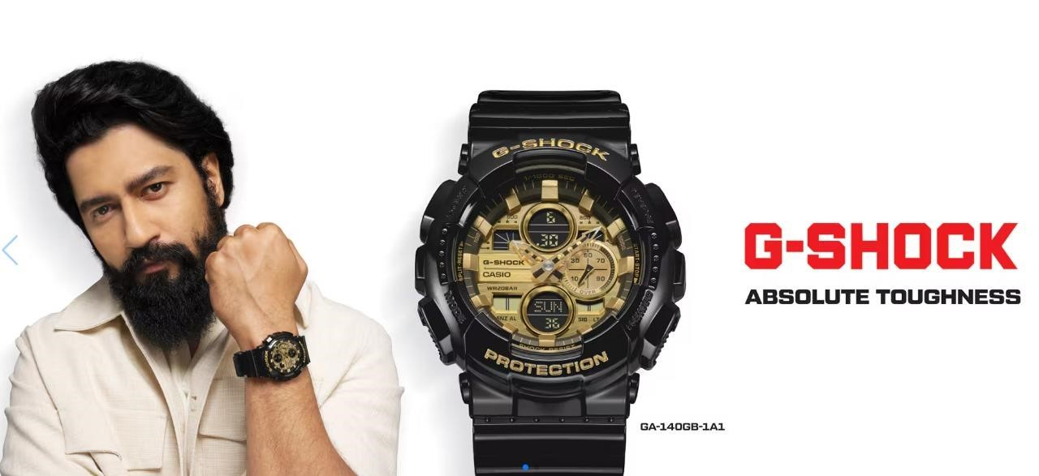

**Chapter – 01 *Introduction***

This chapter gives an overview about the aim and objective of this project.

**1.1 AIM**

The aim of the project, as inferred from the HTML code, is to create a dynamic and engaging G-Shock themed website that serves as a comprehensive hub for Casio brand users . The project's aim is to create an immersive, user-friendly, and comprehensive G-Shock themed website that not only serves as a valuable resource for Casio users but also fosters community engagement and promotes the Casio brand.

## OBJECTIVE

The primary objective of the code is to develop a comprehensive and interactive G- Shock themed website. The website is designed to offer GShock users and engaging platform to explore various G-Shock content, including Watches, Electronic Musical Instruments , calculators, Label Printers and others. G-Shock themed website that serves as a central hub for G-Shock users, promotes G-Shock content, and builds a community around the G-Shock brand.

**The code aims to achieve the following objectives:**

* **User Interface and Experience:**
* **Content Organization and Navigation:**
* **User Interaction and Engagement:**
* **Content Promotion and Marketing:**
* **Community Building:**

## 1.2 Scope and Motivation

○ **Scope:**

The scope of the project encompasses the development of a fully functional and interactive G-Shock themed website. The project includes the following key components:

* **User Interface Development:**
* Design and implement a visually appealing and intuitive layout.
* Ensure responsive design for compatibility across various devices.
* **Content Management:**
* Organize content into distinct sections such as Watches, Electronic Musical Instruments , calculators, Label Printers and others • Implement features to highlight trending and popular Casio products.
* **User Authentication and Interaction:**
* Develop modals for user login and registration.
* Implement search functionality for easy navigation.
* **Promotional Features:**
* Highlight new releases and featured content.
* **Community Engagement:**
* Incorporate social media links to foster community building.
* Provide registration features to create a user community.
* **Support and Information:**
* Include links to help and FAQ sections.
* Inform users about career and internship opportunities at G-Shock.

○ **Motivation:**

The motivation behind this project is driven by several key factors:

 **Users Engagement:**

* Provide G-Shock users with a centralized platform to explore and enjoy a wide range of G-Shock content.
* Enhance users interaction and engagement through an intuitive and interactive user interface.

 **Brand Promotion:**

* Promote Casio’s diverse content, including new releases and popular items.

 **Community Building:**

* Foster a sense of community among G-Shock by users integrating social media links and providing user registration features.
* Encourage users to connect and interact, creating a vibrant and engaged user base.

 **User Experience:**

* Ensure a seamless and enjoyable user experience through responsive design and intuitive navigation.
* Provide support and information to assist users with common questions and issues.

 **Career Opportunities:**

Inform users about career and internship opportunities within G-Shock, , attracting potential talent and fostering interest in the brand.

Chapter – 02 ***Overview of the project***

### Overview of the project

This project aims to create a dynamic, interactive, and engaging platform for G-Shock users worldwide, promoting Casio's content, building a strong community, and enhancing the overall user experience. The primary objective of this project is to develop an interactive, userfriendly, and visually appealing G-Shock themed website. The website aims to serve as a comprehensive platform for G-Shock users to explore, engage with, and enjoy various G-Shock content, including Watches, Electronic Musical Instruments , calculators, Label Printers and others.

### 2.1 Programing language used :-

**HTML** The primary language used in the development of the

Marvelthemed website project is **HTML** (HyperText Markup Language). HTML is the standard language for creating and structuring content on the web.

In addition to HTML, this G-Shock themed website project utilizes **CSS**

**(Cascading Style Sheets)** and **JavaScript** to enhance the website’s appearance and functionality.

**CSS** is used for styling HTML elements, making the web pages visually appealing and user-friendly. It helps separate the content from the presentation, allowing for greater flexibility and control over the design of the website.

**JavaScript** is used to add interactivity and dynamic behavior to the website. It allows for the creation of more engaging and functional web pages by enabling user interactions, manipulating the DOM (Document Object Model), and handling events.

# HTML :-

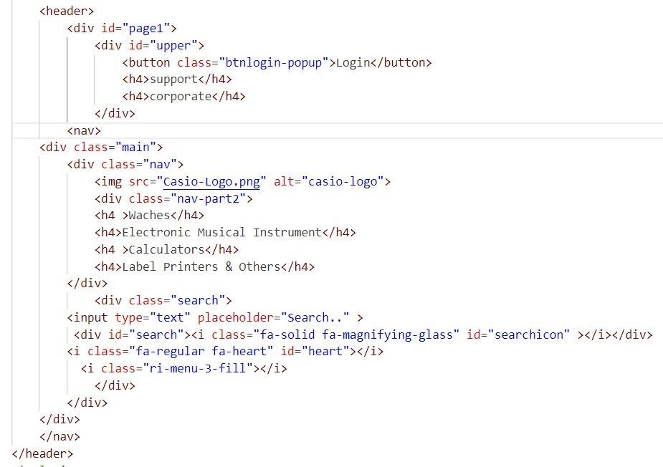

# CSS:-

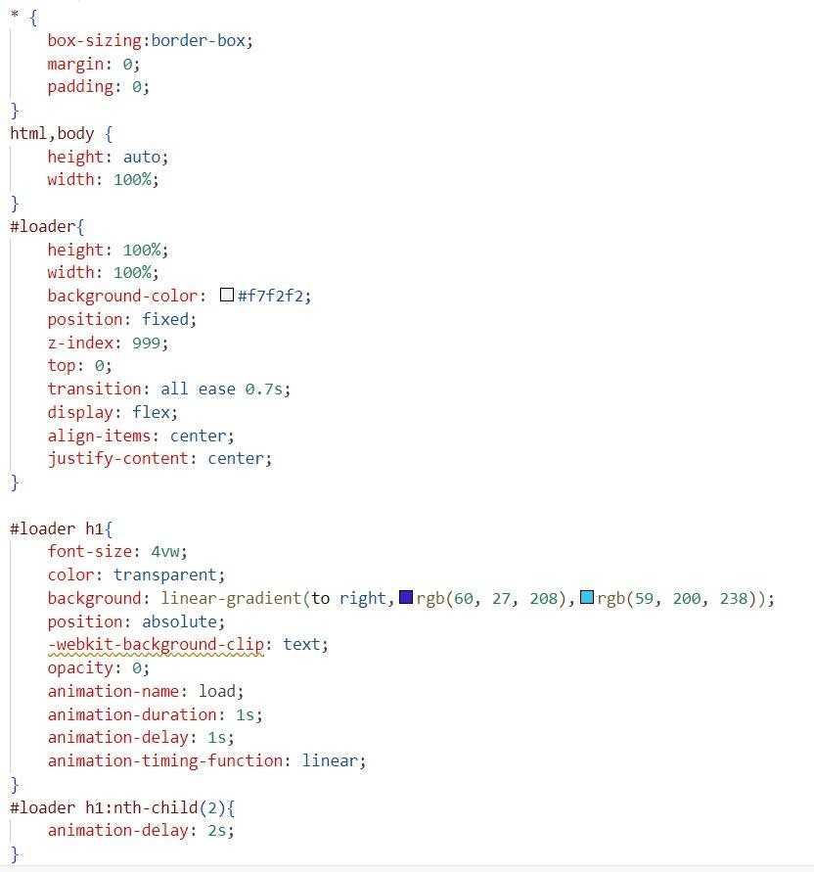

# Javascript:-

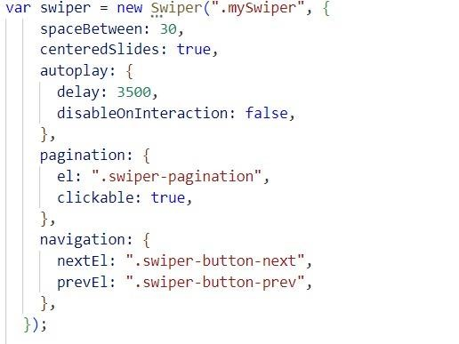

Chapter – 03

Working of the code

The Casio website is a project designed to provide information and interactive features related to Casio brand and their respective watches. Here's a detailed explanation of how the website works: Structure and Layout The website is structured using HTML for content, CSS for styling, and JavaScript for interactivity.

**HTML (HyperText Markup Language):**

* HTML is used to create the structure and content of the web pages.
* It defines various sections of the website such as the header, navigation menu, main content area, and footer.

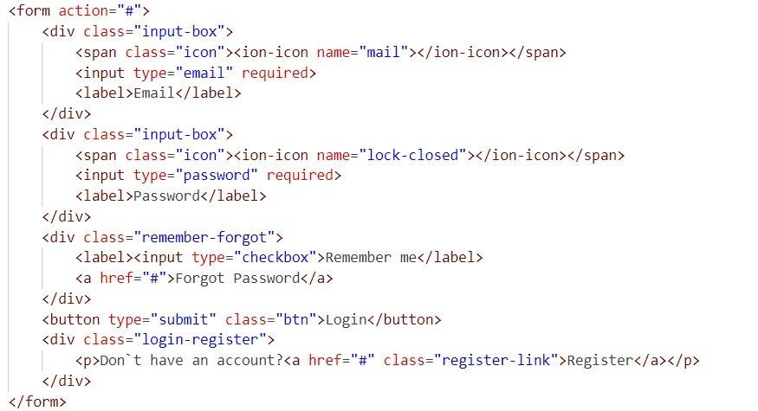

**CSS (Cascading Style Sheets):**

* CSS is used to style the HTML elements and control the layout.
* It ensures a responsive design, making the website look good on different devices and screen sizes.
* CSS also adds visual enhancements such as colors, fonts, spacing, and animations.

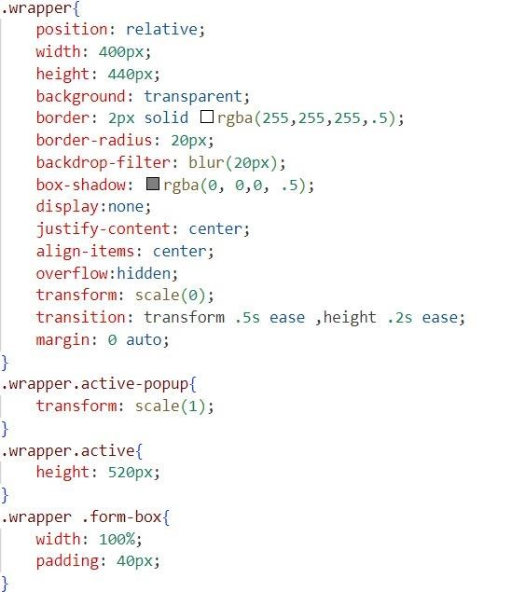

**JavaScript:**

* JavaScript is used to add interactivity and dynamic behavior to the website.
* It handles user interactions, such as clicking buttons, submitting forms, and loading dynamic content.
* JavaScript also manages data fetching and DOM manipulation to update the web pages in real-time.

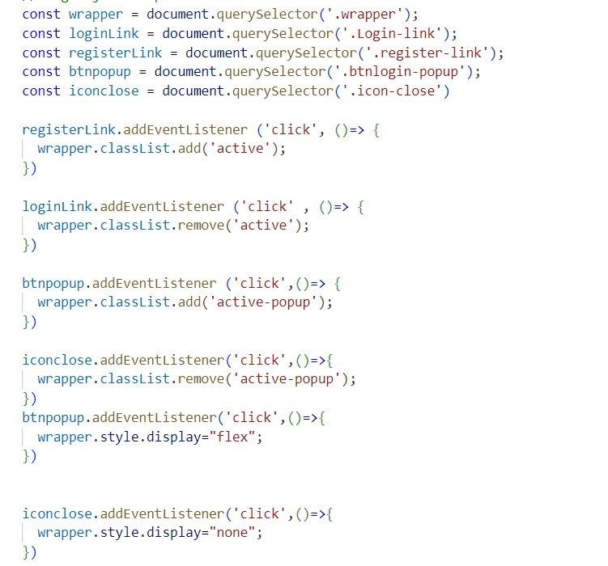

**Key Features and Functionality**

1. **Navigation:**

* The website features a navigation menu that allows users to browse different sections, such as the home page, character profiles, and movies list.
* The navigation menu is styled using CSS and can include dropdowns or collapsible menus for better organization.

2**. Watches List:**

* The Watches list page provides information about Watches includes their prices and their brands.
* Users can click on a watches to view more details, which are dynamically loaded using JavaScript.
* The layout and presentation of the watches list are controlled by CSS.

1. **User Authentication:**
   * The website includes a user authentication feature that allows users to log in and log out.
   * A modal (popup) is used for the login form, which is displayed using JavaScript when the user clicks the login button.
   * JavaScript validates the form inputs and manages the login process.

1. **Dynamic Content Loading:**

* JavaScript fetches data from external sources (e.g., APIs) or local files and updates the web pages without requiring a full page reload.
* This improves the user experience by providing a seamless and interactive browsing experience.

6. **Responsive Design:**

* The website is designed to be responsive, meaning it adapts to different screen sizes and devices.
* CSS media queries are used to adjust the layout and styling based on the device's screen width.
* This ensures that the website is accessible and user-friendly on desktops, tablets, and mobile devices.

Chapter – 04

Website in Society

**Use of the G-Shock-Themed Website in Society**

The G-Shock-themed website is a multifaceted platform that provides Buying details and prices of the watches and other instruments. It promotes learning, creativity, and social interaction, making it a valuable resource for both individual users and the broader community.

**1. Entertainment and Engagement:**

•**User Engagement**: The website acts as a hub for Users, providing them with detailed information about their favorite Watches and instruments.

• **Interactive Features:** Users can interact with various features such as

**2.** **Community Building:**

• **Users Community**: The website can foster a sense of community among Casio Users by offering forums and discussion boards where fans can share their thoughts, theories, and user fiction.

**3. Accessibility and Inclusivity**:

**• Accessible Information**: By providing information about Casio products in an organized and easy-to-navigate format, the website makes this content accessible to a wider audience, including those who may not have access to other sources.

**4. Learning and Development**:

• Technical Skills: Aspiring web developers and designers can learn from the website’s use of HTML, CSS, and JavaScript, understanding how these technologies are applied in real-world projects.